Lambda Expressions with Collections
Example1: Sorting LIST
Sorting Elements of List without lambda: descending order
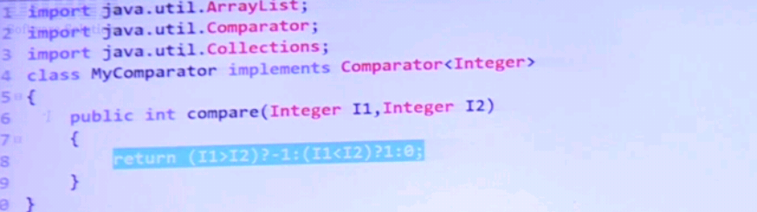
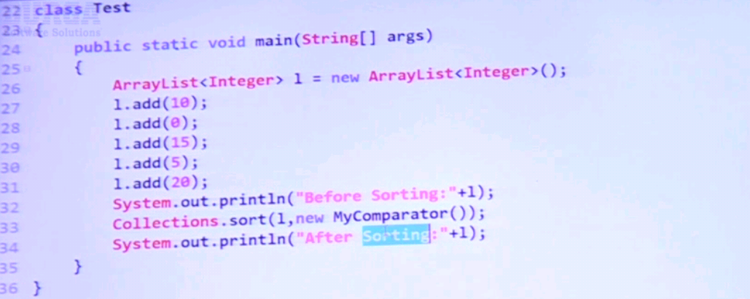

Sorting Elements of List with lambda: descending order
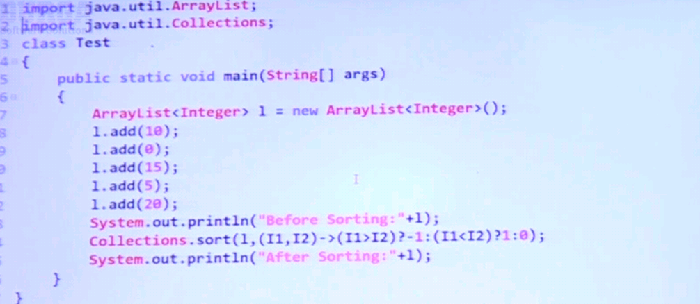
Example 2: Sorting SET
Sorting Elements of Treeset without lambda: default sorting order
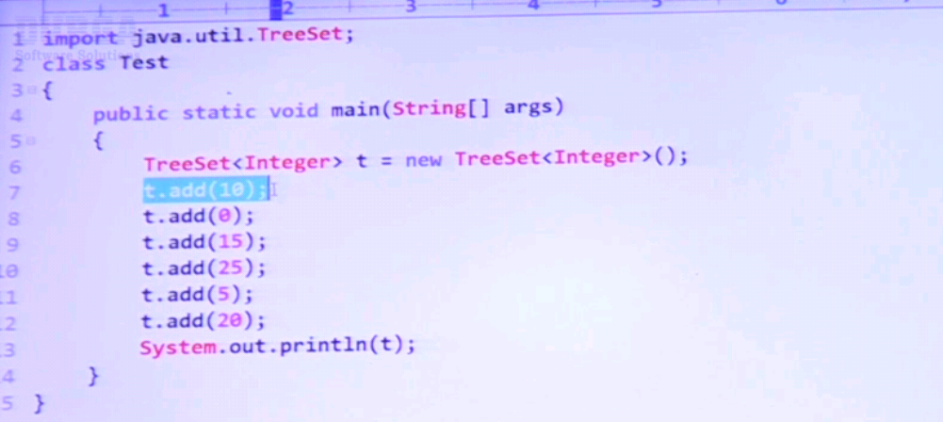
Sorting Elements of Treeset with lambda: descending order
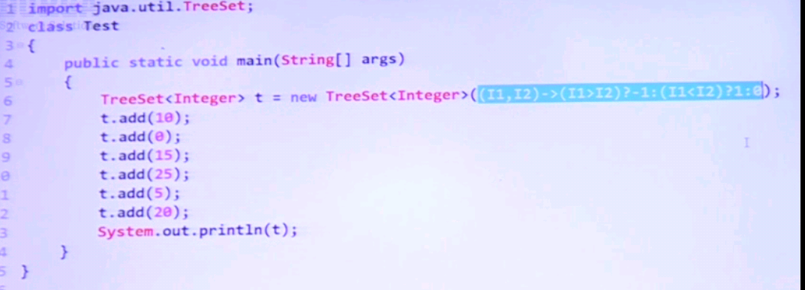

Example 3: Sorting MAP
Sorting Elements of Treemap without lambda: default sorting order
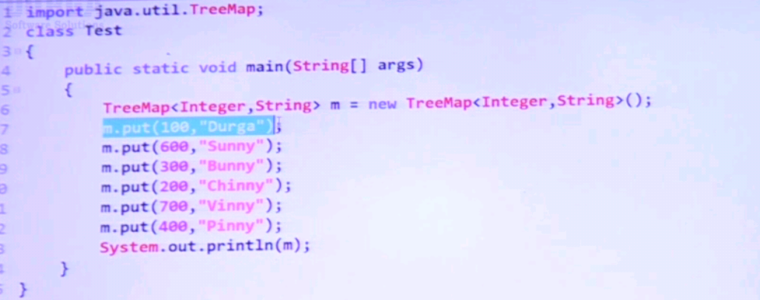
Sorting Elements of Treemap with lambda: descending order
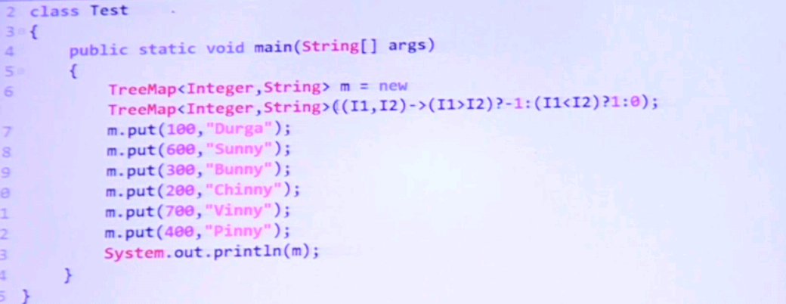

Example 4: Sorting of our own class objects with lambda expression.
